**Remedy Notes**

**Sites**

Go/smpp

**Infoman CRS**

**Decomission**

16751427

**Remedy CRS**

**Decomission**

CRQ001000004961

**CCID**: CCID is last 7 digits of the ticket preceded by #

EG: #0004961

**PackageID :** PackageID is last 8 digits of the ticket.

**Creation of Ticket**

1. **Change Manager**...Please ensure some change manager is selected

2. It is mandatory to provide package id in classification tab of endevor task

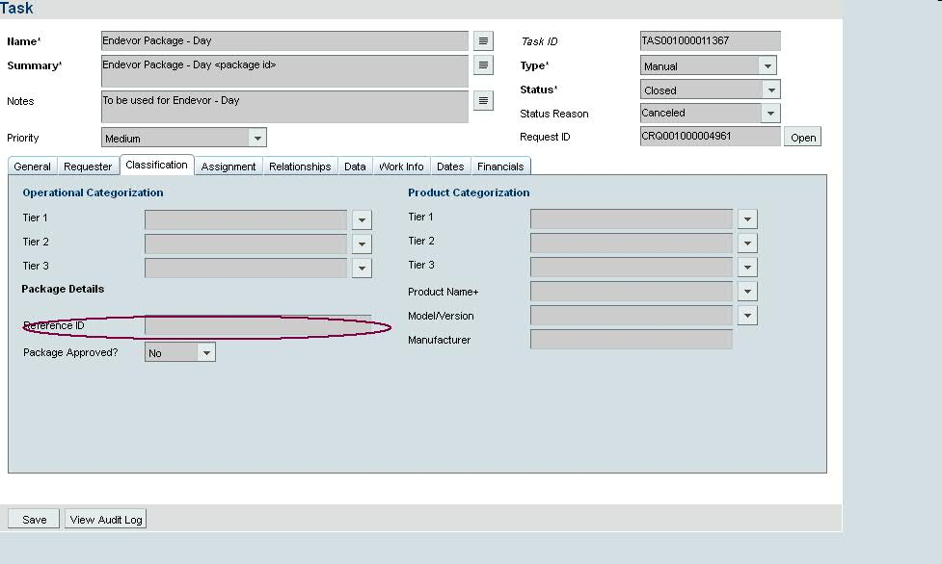

3.